**42nd Austrian Chemistry Olympiad**

**National Competition**



**Problem booklet for the practical part – June 3rd, 2016**

|  |  |  |
| --- | --- | --- |
|  | **bp** | **rp** |
| **9: Qualitative Analysis** |  |  |
| **10: Determination of an analgesic drug** |  |  |
| **11: Synthesis of a yellow, crystalline substance** |  |  |

**Total: .........../40**

**Name:........................................ Number:............**

## Hints

* You have 5 hours to complete the solutions of the competition tasks.
* You may only use this paper, draft paper, a not programmable calculator, a blue or black biro, a pencil, and a ruler, nothing else.
* Write your answers in the boxes provided for them. **Only these answers will be** marked. If you don’t have enough space, then you may write on the draft paper with the remark “belongs to part *x.xx*“, whereby *x.xx* means the part of the task in italics. Add this draft paper to the booklet.
* This booklet contains 8 pages without the front page.
* You have to wear a lab coat and googles (or your optical glasses) all the time.
* All participants with an odd number may use the reflux-station between 8.45-10.45, all participants with an even number, between 10.45-12.45.

**Data and formulae**

*M* (H) = 1,0 g∙mol-1

*M* (C) = 12 g∙mol-1

*M* (N) = 14 g∙mol-1

*M* (O) = 16 g∙mol-1

|  |  |
| --- | --- |
| amount of substance | $n=\frac{m}{M}$ |
| molar concentration | $c=\frac{n}{V}$ |

# Task 9 13 points

**Qualitative Analysis**

Each of 10 PPP contains one substance in aqueous solution. In addition to the ions from the autoprotolysis of water the solution can contain more than two kinds of ions.

The following ions can be present:

H3O+,K+, Na+, NH4+, Ag+, Zn2+, Ca2+, Ba2+, Pb2+, Cu2+, Co2+, Ni2+, Mn2+, Fe2+, Fe3+

OH–, NO3–, Cl–, Br–, I–, SO42–, HSO42–, CH3COO–, C2O42–, ClO4–, CO32–, PO43–, H2PO4–, CrO42-, Cr2O72-

For the analysis you can use:

|  |  |
| --- | --- |
| * pH-paper * the samples themselves * tweezers * kitchen roll | * sheet for spot analysis * apparatus for electrolysis * deionized water * little coffee stirrers |

The following reagents can be obtained from the lab assistant but you will be „charged“ 3 blue points for each. For your information: The whole problem is worth 39 bp at maximum

|  |  |
| --- | --- |
| * NaClO4 saturated solution * BaCl2 0,1 M | * KMnO4 0,02 M * FeCl3 0,5 M |

In a flame-test one sample shows an intense yellow flame, two other samples have lilac flames

.

*Write correct formulae for the identified ions into the following table.*

|  |  |  |
| --- | --- | --- |
| **sample** | **cation** | **anion** |
| **1** |  |  |
|  |  |
| **2** |  |  |
|  |  |
| **3** |  |  |
|  |  |
| **4** |  |  |
|  |  |
| **5** |  |  |
|  |  |
| **6** |  |  |
|  |  |
| **7** |  |  |
|  |  |
| **8** |  |  |
|  |  |
| **9** |  |  |
|  |  |
| **10** |  |  |
|  |  |

# Task 10 14 points

**Determination of an analgesic drug**

**General**

Paracetamol (4-(N-Acetyl)aminobenzenol, *M* = 151.16 g·mol-1) is one of the most used analgesics. Its quantitative determination may be carried out in different ways, one of them is used in this task.

In this determination the amide group is first hydrolysed under acidic catalysis, then the emerging p-aminophenol is oxidised quantitatively using Ce(IV) to give the iminochinone (reaction scheme below). The paracetamol-sample is not pure. You should determine the content of the analgesic.

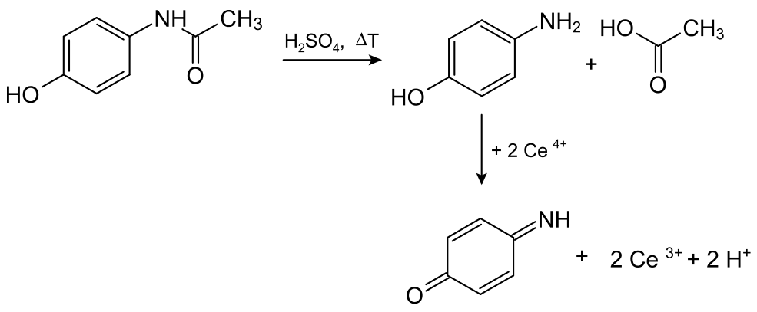

As the Ce(IV)-solution is made from ammonium hexanitrocerate(IV) ((NH4)2[Ce(NO3)6]), which is not a primary titer, the exact concentration of the titer (*c* ≈ 0,05 M) must be determined too.

**Carefully read the procedure before starting your work and consider a reasonable time management.**

**Procedure**

**a) Determination of the Ce(IV)-concentration**

You have 2 burettes at hand, one for the Ce(IV)-solution, the other one for a Na2S2O3-solution (0.05 M, exact concentration will be announced). Choose the burette with the glass tap for the Na2S2O3-solution, the one with the teflon tap for the Ce-(IV)-solution.

10.00 mL of the Ce(IV)-solution are mixed with 10 mL H2SO4 (2 M), 20 mL KI (10%) and 20 mL of deionized water in the titration flask. The iodine precipitated is titrated with the Na2S2O3-solution (0.05 M), whereby 2 mL of starch solution are added immediately before the endpoint as usual (*V1).*

**b) Determination of paracetamol:**

500 mg of the paracetamol-sample (80-90%) were weighed into a 100 mL round bottom flask with stopper. 25 ml of water (one test tube full) and 20 ml of sulphuric acid 2 M are added. Then the flask is brought to the reflux station and assembled with the heating mantle and the reflux condenser. The mixture is heated at level 3 until boiling then the level reduced to 1, where it is held for 20 minutes.

After 20 minutes the heating mantle is lowered, the flask is allowed to cool down a bit, and then removed (caution: hot!). The stoppered flask is cooled down to room temperature using cold water (cold water bath). Eventually, the cooling water must be replaced. Then the content of the flask is transferred quantitatively into a 100 mL measuring flask.

After filling to the mark and homogenising, 10.00 mL are taken out and mixed with 20 mL of deionised water, 10 ml of 2 M hydrochloric acid, 2 ice cubes (made from deionised water), and 2 droplets of ferroin solution (Fe(II)-phenanthrolin-complex).

The following titration with 0.05 M Cer(IV)-solution is carried out quickly as much as possible. The solution changes its colour from orange-red to yellowish-green at the equivalence point (= *V2*).

The fully titrated solutions may be discharged into the sink.

*Fill in the* ***protocol****:*

|  |  |
| --- | --- |
| Tick the right inequation: | |
|  |  |
|  |  |
|  |  |
|  |  |

|  |  |
| --- | --- |
| The addition of the ice cubes is done, because (tick the right statement) | |
|  | Ce(IV)-solution reacts more quickly at low temperatures. |
|  | oxygen from air, which is agitated into the solution while titrating, oxidises the p-aminophenol. |
|  | Ce(IV)-solution more slowly at low temperatures. |
|  | indicator changes its colour more effectively using the ice. |

|  |  |
| --- | --- |
| Chosen *V1*: | Chosen *V2*: |
| Balanced equation Ce(IV) - iodide: | |
| Balanced equation I2 - thiosulphate: | |
| Proportion Ce(IV) - thiosulphate: | |
| Calculation of the concentration of the Ce(IV)-solution: | |
| Calculation of the amount of paracetamol in the measuring flask: | |
| Calculation of the content of paracetamol in the sample in mass percentage: | |

# Task 11 13 points

**Synthesis of yellow crystals**

**1. Principle:**

In this reaction, veratrole (1,2-dimethoxybenzene) is reacted with nitric acid (40%). The resulting product has a molar mass of *M* = 183,16 g/mol.

**2. Procedure:**

a) Synthesis of the crude product:

* In order to prepare an ice-water-bath put five ice cubes and water in the plastic dish. The dish should then be half filled.
* In a 50 mL Erlenmeyer flask there are 3.45 g veratrole (1,2-dimethoxybenzene, *M* = 138,17 g/mol). For TLC analysis an Eppendorf tube **„E“** was filled with one droplet veratrole.
* Cool down the 40% nitric acid containing test tube („HNO3“) and the Erlenmeyer flask with veratrole in the ice-water-bath for five minutes.
* Then add 8.5 mL of nitric acid while stirring (magnetic stirrer). In order to avoid heating of the reaction mixture, add the nitric acid drop-wise using a plastic Pasteur pipette (**one drop in two seconds**).
* After addition is completed continue stirring for another 30 minutes. Leave the reaction mixture in the ice-water-bath.
* Cool down water in the 150 mL beaker by adding ice cubes. Remove the remaining ice cubes with a spoon before using the cooled water.
* Then, pour the reaction mixture in the cooled water containing 150 ml beaker using a glass rod.
* Filter off the precipitated crude product through a Buchner funnel using suction. Then, wash the solid with plenty of cold water, until the filtrate is *pH*-neutral. Take on drop of the filtrate from the bottom side of the Buchner funnel on the glass rod and place it on a piece of indicator paper.

|  |
| --- |
| *3.1. Write down the reaction equation for this synthesis using constitutional formulae.* |
|  |

|  |
| --- |
| *3.2. Tick the right answers concerning the following question. Why was the starting substance 1,2-dimethoxybenzene not brought into reaction with nitro-sulphuric acid, a mixture of nitric acid and sulphuric acid?* |
| *…to cause multiple nitration, because nitro-sulphuric acid is less reactive than nitric acid.*  *… to avoid multiple nitration, because methoxy groups activate the aromatic.*  *… to avoid multiple nitration, because methoxy groups have a (-M)-effect.*  *… to avoid multiple nitration, because nitro-sulphuric is less reactive than nitric acid.* |

|  |
| --- |
| *3.3. Calculate the yield in g and % of the theory.* |
| *Mass tare:_____________________*  *Mass product:_________________*  *Calculation:* |

|  |
| --- |
| *3.4. Determine the melting point of your product:* |

|  |
| --- |
| *3.5. Calculate the RF-values.* |
| *Rf-value of starting substance:*  *Rf-value of product:* |