Macintosh HD:Users:schoeb:Documents:LaTeX:Logos:OECHO Logo.pdf

45th Austrian Chemistry Olympiad

National Competition

Theoretical Tasks

May 30th, 2019

|  |
| --- |
| Name |

|  |  |  |  |  |  |  |
| --- | --- | --- | --- | --- | --- | --- |
|  |  | bp | / | rp | / | rpmax |
| 1 | Mendeleev and the Elements |  | / |  | / | 7 |
| 2 | Organic Chemistry and Music |  | / |  | / | 21 |
| 3 | Copper and other Elements |  | / |  | / | 4 |
| 4 | Energy and Conjugated Systems |  | / |  | / | 10 |
| 5 | Tartar Equilibrium |  | / |  | / | 7 |
| 6 | Kinetics |  | / |  | / | 5 |
| 7 | Evaporating and Cooling |  | / |  | / | 6 |
| Overall Score: | | | |  | / | 60 |

Important Notes

* You have five hours to solve the problems and may use the following tools:
  + Non-programmable calculator
  + Collection of formulae and periodic table handed out to you
  + Concept paper
  + Writing utensil (pencil, blue- or black-coloured pen, ruler or set square, eraser)
* Wherever you are told to do calculations („Calculate…“), write into the corresponding boxes ***in a COMPREHENSIBLE way***, otherwise **you will lose scoring points**.
* If final results require (physical) units, clearly state them. Otherwise you will **lose scoring** **points**.
* Please underline final results.
* Only **answers written into the boxes** will be used for scoring.
* If you run out of space in an answer box, write the solution to the problem on concept paper. **Write your name** on top of that paper. Clearly and unmistakably mark the answer with the corresponding problem number x.xx

Problem 1 7 Points

Mendeleev and the Elements

A. Mendeleev and his Rare Element

As early as 1869, Dmitri Ivanovich Mendeleev predicted an element with an atomic mass of m=44u that he called Eka-Boron. However, it took some time until Per Teodor Cleve realized that Eka-Boron matches with Scandium, whose nucleus has a mass of m=44.9559u.

|  |
| --- |
| 1.1 Calculate the binding energy of the 45Sc nucleus in MeV |
|  |

Scandium crystallizes in a hexagonal closed packed lattice. Its unit cell has a diamond-shaped base and its volume is V=5.002.10-23cm3.

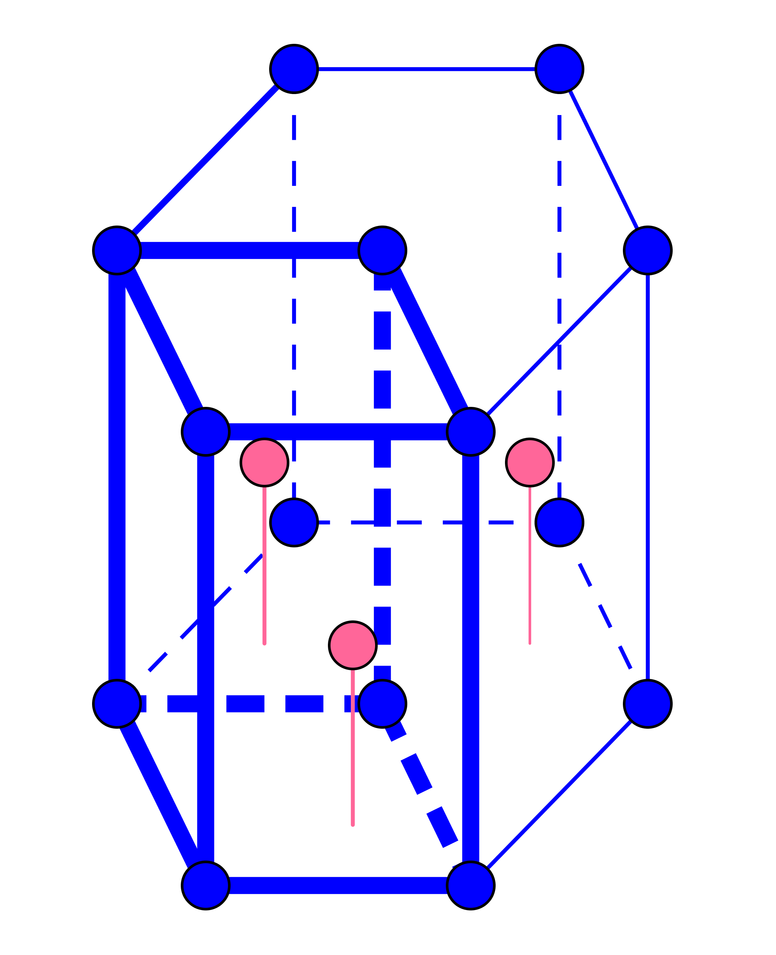

|  |
| --- |
| 1.2 Calculate the coordination number of Scandium. |
|  |
| 1.3 Determine the number of atoms in the unit cell. |
|  |
| 1.4 Calculate the density of Scandium. |
|  |

Scandium exists in many different compounds.

|  |
| --- |
| 1.5 Add empirical formulae, names and general product names to the table below. |
| |  |  |  | | --- | --- | --- | | Name incl. oxidation no. of the cation | Formula | Product | |  | Sc(NO3)3 |  | | Scandium(III)oxide |  | a salt | |  | [ScF6]3– |  | | Trioxalatoscandate(III) |  | .......................... complex | |

One can produce Scandium by reducing the Fluoride with Calcium.

|  |
| --- |
| 1.6 Formulate a balanced equation for this reaction. |
|  |

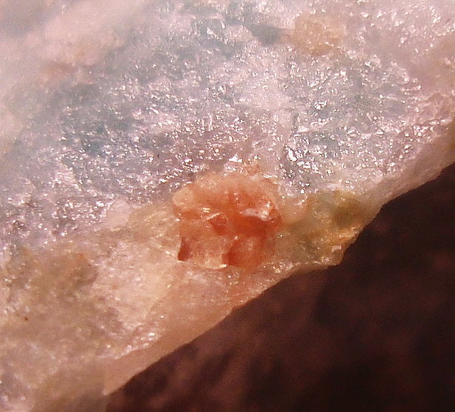Scandium is a rare earth element. It does not occur in nature as the pure element. Some minerals contain it as its phosphate, silicate, or carbonate. Only five minerals contain Scandium as the main component – the pinkish Pretulite is one of them. Pretulite was first discovered on the Pretul Alp (Fischbach Alps, Styria, Austria), and has the empirical formula Sc[**A**]y (**A** = Anion containing Oxygen and another element).

Pretulite crystallizes in a tetragonal lattice with the following lattice parameters $a=b=6.589∙{10}^{-10}m$, $c=5.806∙{10}^{-10}m$, $α=β=γ=90°$; It comprises 4 formula units per unit cell. Its density is $ρ=3.688 \frac{g}{{cm}^{3}}$. Hence, the mass of 4 Sc[**A**]y per unit cell is $m=\frac{4M}{N_{A}}$.

|  |
| --- |
| 1.7 Determine the molar mass of Pretulite. |
|  |
| 1.8 Elementary analysis revealed that Pretulite contains 32% (m/m) Scandium. Determine the empirical formula of Pretulite. |
|  |

During the Solvex process, one irradiates 45Sc with neutrons to obtain substrate-free 45Ca.

|  |
| --- |
| 1.9 Formulate an equation for this nuclear transformation. |
|  |

Artificially produced Scandium 46 has a half-life of 83,8d and yields Titanium 46.

|  |
| --- |
| 1.10 Formulate the equation for this nuclear decay and state the type of decay. |
|  |

B. From Scandium to Titanium

The Ti3+ cation forms a complex in aqueous solution: [Ti(H2O)6]3+. Several theories exist to describe complex formation. This problem will consider both valence binding theory and crystal field/valence field theory. The ligand field splitting parameter of [Ti(H2O)6]3+ is 234kJ/mol.

|  |
| --- |
| 1.11 Label the Pauli valence binding diagram and complete it for the given complex. |
| |  |  |  |  |  |  |  |  |  |  |  | | --- | --- | --- | --- | --- | --- | --- | --- | --- | --- | --- | |  |  |  |  |  |  |  |  |  |  |  | |
| 1.12 Determine hybridization of the central atom. |
|  |
| 1.13 Specify the magnetic behavior of the complex. |
|  |
| 1.14 Specify the spatial structure of the complex. |
|  |
| 1.15 Name the complex. |
|  |
| 1.16 Draw the energy level diagram showing the configuration of the d electrons of the metal ion in the complex and denominate the respective types of the energy states. |
|  |
| 1.17 Calculate the wavelength of the light the complex absorbs. |
|  |
| 1.18 Determine the color of an aqueous solution of this complex. |
|  |

Most known titanium complexes comprise inorganic ligands. However, there are also a few titanium complexes containing organic ligands, such as Pentamethyl titanate(IV).

|  |
| --- |
| 1.19 Sketch two possible spatial structures of [TiMe5]– (Me … methylide anion). Name the respective geometrical shapes. |
|  |

Problem 2 21 Points

Organic Chemistry and Music

A. AB(B)A – „Take a Chance on Me“

**Phytohormones** are organic compounds produced by plants; They are primary messengers that regulate and coordinate both how a plant grows and develops.

**Abscisic acid (ABA)** is an inhibitory phytohormone. Chemically speaking, it is a monocyclic sesquiterpene, i.e. based on three isoprene units. Comprising more than 3000 compounds, sesquiterpenes constitute the largest subgroup of terpenes.

In contrast to many other phytohormones, abscisic acid is a single compound rather than a group of compounds.

A.1. Synthesis of ABA (refer to the scheme on the next page):

Synthesis starts from two precursors, namely 4-Methyl pent-3-ene-2-one (compound **B**) and compound **A**, whose structure can be determined from the 1H- and 13C-NMR spectra given.

Hints on Synthesis:

* **C** and **D** are position isomers (C12H18O3). They contain a carbocycle comprising 6 carbon atoms in the ring, respectively.
* The IR spectrum of **G** shows an absorption band at 1730 cm-1.
* **G**→**H**: This reaction leads to an additional heterocycle containing 6 ring atoms.
* **J**: Element analysis: C: 68.16%; H: 7.63%; O: 24.21% (w/w)

Spectra of compound **A**:

* 1H-NMR: 500 MHz, CDCl3; δ (ppm) = 1.2 (3H, t); 2.3 (3H, s); 3.41 (2H, s); 4.11 (2H, q).
* 13C-NMR: 125 MHz, CDCl3 δ (ppm) = 14.1; 30.0; 50.0; 61.0; 168; 200.



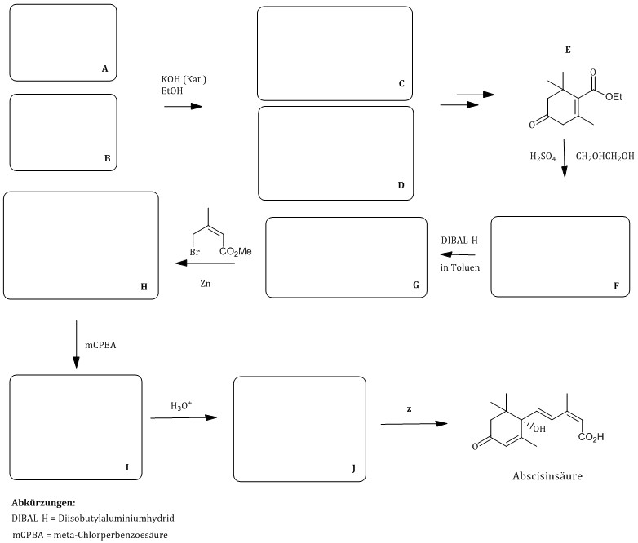

Abscisic acid

**Acronyms:**

mCPBA … meta-chloroperbenzoic acid

DIBAL-H … Diisobutyl aluminium hydride

in toluene

|  |
| --- |
| 2.1 Determine the structural formula of **A** (reaction scheme) and assign both 1H- and 13C-shifts to the respective atoms. |
|  |
| 2.2 Draw the structural formula of **A** when using a 1:1 mixture of D2O/CD3CN as the solvent during NMR measurements. |
|  |

|  |
| --- |
| 2.3 Give the empirical formula of **J**. |
|  |

|  |
| --- |
| 2.4 Determine the structural formulae **B** to **J**. Keep the correct stereochemistry in mind (reaction scheme). |

|  |
| --- |
| 2.5 Suggest a reagent **z** to transform **J** to Abscisic acid (reaction scheme). |
|  |

|  |
| --- |
| 2.6 The step from **E** to **F** comprises introducing a widely used protective group. Which concrete reaction during the following reaction process does it prevent from happening? |
|  |
| 2.7 Demonstrate the reaction mechanism leading from **E** to **F**. Do not draw the entire molecule, but only the respective functional group and the corresponding residues. |
|  |
| 2.8 Which reaction mechanism do the two reactions below follow? Use standard acronyms. |
| **F**→**G**: **G**→**H**: |

Below please find IR data of **E** and two of its isomers (**E´** and **E´´**). They comprise C—O—C valence bands (stretching) and C=O valence bands (ketones, aldehydes):

* 1050-1250 cm-1
* 1680 cm-1
* 1715 cm-1
* 1730 cm-1

|  |
| --- |
| 2.9 Assign the respective wave numbers to the corresponding functional group by writing them to the correct position of the respective structure of each of the three isomers. |
| *D:\Bundeskoordinatorenteam_Olympiade\Bundeswettbewerb 2019\Wettbewerb Theorie\Ende IR-Strukturen.png* |

|  |
| --- |
| 2.10 Well-known effects in Organic chemistry cause the differences in the spectral range at 1700 cm–1. Which of the following statements is true, and which one is false? Write “t” for “true” and “f” for “false”. |
| |  |  | | --- | --- | | **t / f** | **Statement** | |  | Band shift to wavenumber 1730 cm-1 is a consequence of the –I effect. | |  | C=O groups binding to two Alkyl groups absorb at lower wavenumbers, than C=O groups binding to one alkyl group. | |  | Band shift to wavenumber 1680 cm-1 is a consequence of the –I effect. | |  | Band shift to wavenumber 1730 cm-1 is a consequence of the +M effect. | |  | Band shift to wavenumber 1680 cm-1 is a consequence of the +M effect. | |  | Conjugation shifts wavenumbers to higher values. | |  | An absorption band of F2C=O occurs at lower wavenumbers, than that of (CH3)2C=O. | |  | Conjugation shifts wavenumbers to lower values. | |

**A.2. Determining the structure of ABA:**

Ozonolysis of Abscisic acid followed by oxidative processing yields three products **X**, **Y** and **Z**.

1.0000 g **X** yields 1.7872 g CO2 and 0.5123 g H2O after combustion. Its molar mass is m=246.24 g/mol.

Alkaline solution of **Z** leads to a hardly soluble residue with Calcium nitrate solution.

|  |
| --- |
| 2.11 Calculate the empirical formula of ozonolysis product **X**. |
|  |
| 2.12 Give the structural formulae of ozonolysis products **X**, **Y** and **Z**. |
|  |

|  |
| --- |
| 2.13 Write the stereodescriptor(s) of Abscisic acid into the figure. |
|  |
| 2.14 How many enantiomers of Abscisic acid exist? |
|  |
| 2.15 How many stereo isomers exist for the constitutional formula of Abscisic acid? |
|  |

**A.3. ABA Mechanism of action**

Ripe fruit and abscission layers produce the phytohormone Abscisic acid just as Ethene, a gas. Abscisic acid is responsible for trees shedding their leaves and fruit in autumn. In addition to falling leaves and ripening of many fruit, degradation of chlorophyll, the leaf pigment, takes place in autumn. This leads to so-called chlorophyll catabolites. Actually, senescent leaves forming in autumn and biosynthesis of chlorophyll in spring represent the most impressive and spectacular color changes in nature. They are a sign of life that is even visible from space. The following figure shows a particular chlorophyll catabolite of the wych elm (**Catabolite 1**).

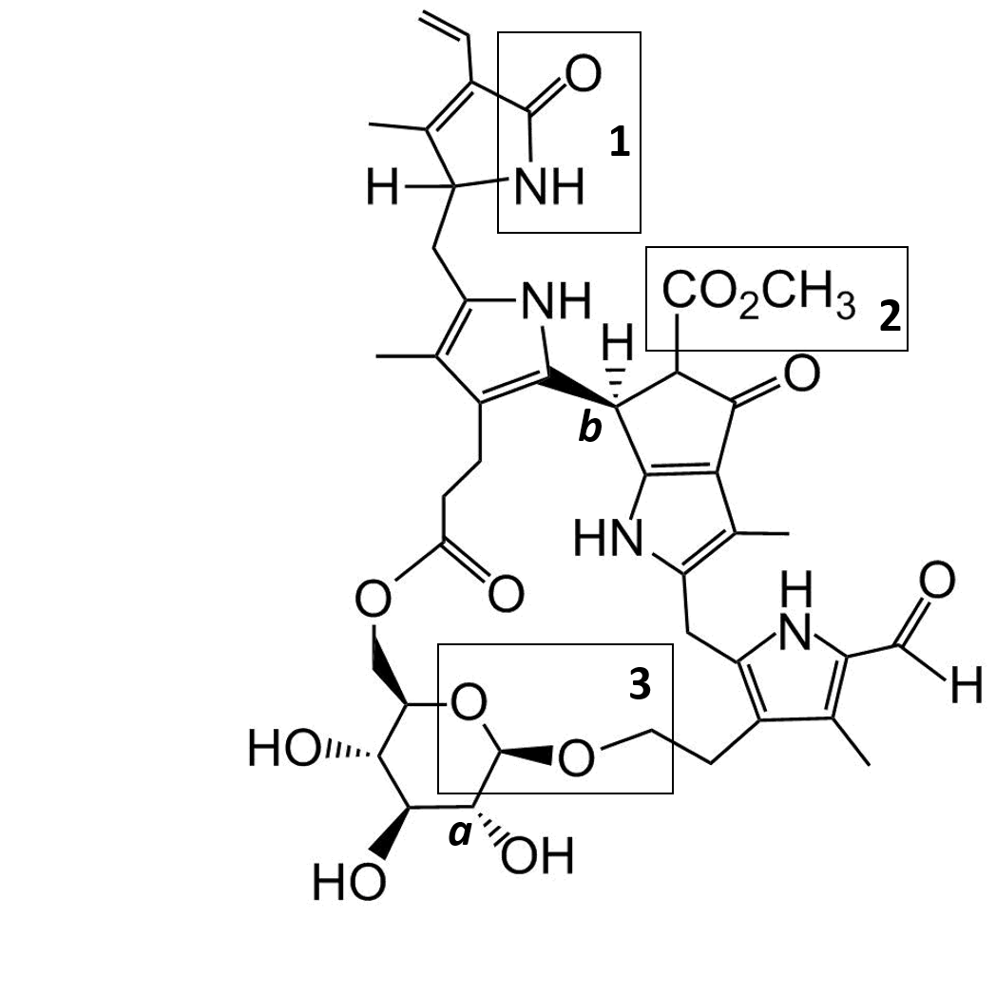

|  |
| --- |
| 2.16 Name the functional groups labeled with **1**, **2,** and **3**, respectively. |
|  |
| 2.17 Determine the stereo descriptors of the C atoms labeled **a** and **b**. |
|  |
| 2.18 Determine the number of stereogenic centers and label them with an asterisk (\*) in the structural formula. |
|  |

|  |
| --- |
| 2.19 Calculate the maximum number of possible stereoisomers of this catabolite based on the assumption that glucose is always present in its D-configuration and can only form different anomers. |
|  |

Regard the 600 MHz 1H-NMR spectrum of **Catabolite 1** in CD3OD:

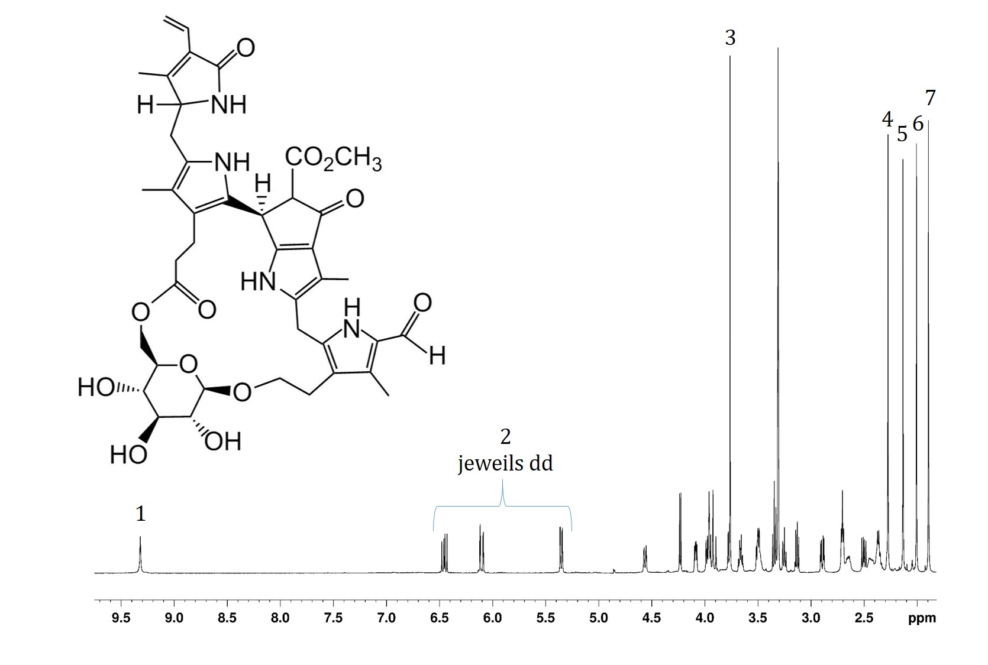

dd each

|  |
| --- |
| 2.20 Assign the numbered signals in the 600 MHz-NMR-Spectrum to the respective structure by writing the numbers to the respective protons. It is not possible to assign all 7 signals explicitly. |
|  |
| 2.21 The structure contains hydrogen atoms, whose signals are not visible when recording the NMR spectrum in a protic deuterated solvent, such as CD3OD. Mark those hydrogen atoms by encircling them in the structural formula. |
|  |

Wych elm leaves reveal oxidative activity. Therefore, catabolite 1 leads to the following **oxidation product**:

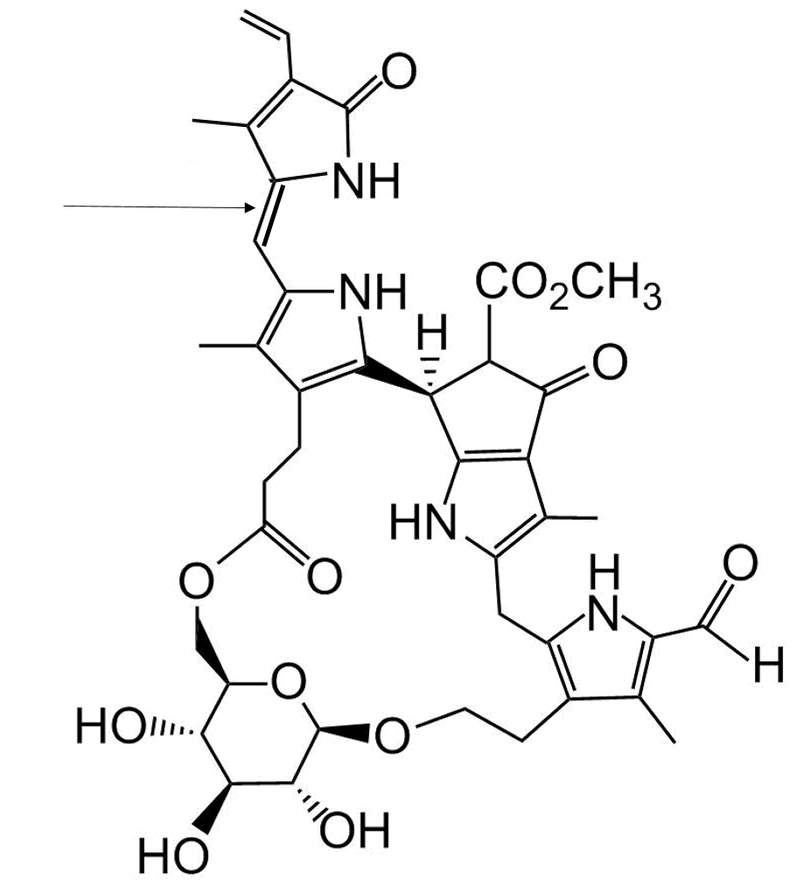

|  |
| --- |
| 2.22 Determine the stereodescriptor at the position of the arrow. |
|  |

Photoisomerization, which can be assessed by photometry, leads to a special isomer.

|  |
| --- |
| 2.23 State which type of isomeism is present. |
|  |

Recording the UV/Vis spectra of **Catabolite 1** and its **oxidation product** in the laboratory gives the following results:

|  |
| --- |
| 2.24 Correctly assign „Catabolite 1“ and „Oxidation product“ to the spectra. |
| C:\Users\Mathias\Dropbox\Dissertation\Ulme\UV_CD\UV&CD_Spektrum_Ug-NCC-3kombiniert_21.1.2016.png |
| 2.25 Deduce the color of each derivative. |
| Catabolite 1: \_\_\_\_\_\_\_\_\_\_\_\_\_\_\_\_\_\_\_\_\_\_\_\_\_\_\_  Oxidation product: \_\_\_\_\_\_\_\_\_\_\_\_\_\_\_\_\_\_\_\_\_\_\_\_\_\_\_ |
| 2.26 One of the two compounds requires less energy for electronic excitation. Calculate the the energy of the photon that excites at the absorption maximum. Explicitly state the wavelength underlying your calculation. State the color of the exciting light. |
|  |

B. „Let´s twist again“

Twistane belongs to the class of **polycyclic compounds**; The carbon atoms of molecules belonging to this class are arranged in several rings. The systematic name of Twistane – a gorgeously twisted hydrocarbon - is Tricyclo[4.4.0.03,8]decane.

The following figure summarizes the synthesis sub-steps.

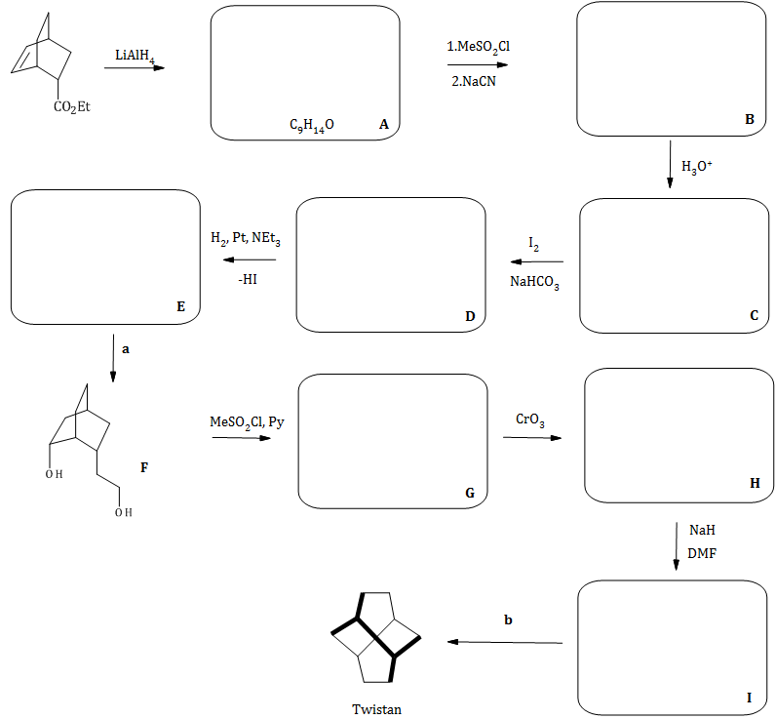

Twistane

Clues: In transformation **F**→**G**, the reaction occurs only at the sterically more accessible hydroxyl group. In reaction **H**→**I**,DMF (N,N-Dimethylformamide **=** *N*,*N*‑Dimethyl acetamide) is the solvent.

|  |
| --- |
| 2.27 Determine the structural formulae **A-E** and **G-I** (reaction scheme) taking into account correct stereochemistry. |
| 2.28 Name the reaction mechanism in the second step of **A**→**B**! Draw the structure of the transition state. |
|  |
| 2.29 Suggest reagents **b** for transforming **I** to Twistane; What is this name reaction called und what is the underlying mechanism (first step)? |
|  |

|  |
| --- |
| 2.30 What role does NaH play during step **H**→**I**? Tick the correct answer(s). |
| |  |  | | --- | --- | | □ | Oxidant | | □ | Reductant | | □ | Acid | | □ | Base | | □ | Protective group | | □ | Catalyst | |

|  |
| --- |
| 2.31 Determine the symmetric elements of Twistane. |
|  |

Problem 3 4 Points

Electrochemistry: Copper and Other Metals

A. Composition of a 10-cent coin.

Coins of denominations 10, 20, and 50 cents consist of so-called Nordic Gold, an alloy of copper, zinc, aluminum, and tin. The aim of this problem is to determine the composition of this alloy in %(m/m).

In a first step, a 10-cent-coin weighing 4.100 g is dissolved in diluted hydrochloric acid. This generates 363.9 mL Hydrogen (Pressure p=1.013 bar; 298 K).

The undissolved residue (a reddish metal) is completely dissolved in concentrated nitric acid and then electrolyzed after appropriate pre-treatment.

Completely depositing it on the cathode requires 16.71 minutes at a current of I=13A and 85% current efficiency.

*N*-Benzoyl-*N*-phenylhydroxylamine (C6H5CON(OH)C6H5) precipitates tin dissolved in the hydrochloric acid and yields the complex (C13H11O2N)2SnCl2. This results in 0.213 g of the complex (*M* = 616.11 g mol-1).

|  |
| --- |
| 3.1 Formulate balanced equations for dissolving the soluble components of the coin in diluted hydrochloric acid. |
|  |
| 3.2 Specify the electrolyzed metal and calculate its mass fraction in the alloy. |
|  |

|  |
| --- |
| 3.3 Calculate the mass fraction of tin in the coin. |
|  |
| 3.4 Calculate the mass fractions of the remaining two metals in the coin. |
|  |

B. Electrochemistry of Real Gold

Coins made from real gold dissolve neither in hydrochloric acid, nor in nitric acid.

Below you find the incomplete Latimer diagram at pH = 0. All potentials are given in Volt.

$${Au}^{3+}\underset{→}{ x }{Au}^{+}\underset{→}{ +1.830 }Au$$

+1.517

|  |
| --- |
| 3.6 Calculate the missing potential x. |
|  |

Gold does not dissolve in nitric acid (better: it does not react with it), but it does dissolve in Aqua Regia, a mixture of concentrated hydrochloric and nitric acids (ratio 3:1) developed by alchemists to “dissolve” gold.

The reaction with aqua regia yields [AuCl4]–.

Data:

*EO* (Au3+/Au) = + 1.517 V

*EO* ([AuCl4]–/Au) = + 1.002 V

|  |
| --- |
| 3.7 Calculate the complex forming constant of [AuCl4]– at 298 K from the given standard potentials. |
|  |

Problem 4 10 Points

Energy and Conjugated Systems

A. Propene

Propene is regarded one of the most important raw materials for organic secondary products. The estimated annual world production is more than 50 million (metric) tons. There are several ways to produce propene. Olefin metathesis is one possible way:

CH2=CH2 (g) + CH3-CH=CH-CH3 (g) → 2 H2C=CH-CH3 (g)

Find some thermodynamic data at 298 K for your further calculations:

|  |  |  |  |  |
| --- | --- | --- | --- | --- |
|  | Δf*H* ° /kJ mol–1 | Δc*H* ° /kJ mol–1 | *S* ° /J K–1 mol–1 | *Cp* ° /J K–1 mol–1 |
| Ethene (g) | 52.4 |  | 219.3 | 42.9 |
| But-2-ene (g) | –7.7 |  | 301.0 | 80.2 |
| Propene (g) | 20.4 | –2058.0 | 266.8 | 64.3 |
| Propane (g) |  | –2220.0 |  |  |
| H2 (g) |  | –286.5 |  |  |

|  |
| --- |
| 4.1 Calculate ΔrH°, ΔrS°, and ΔrG°, as well as Kp at 298K. |
|  |

In reality, the reaction takes place at higher temperatures, such as 436K.

|  |
| --- |
| 4.2 Calculate the heat that is set free at isobaric conditions when producing 1000kg Propene at 436K. |
|  |

Catalytic dehydrogenation of Propane is another way to produce Propene:

C3H8(g) → C3H6(g) + H2(g)

|  |
| --- |
| 4.3 Calculate ΔrH° and ΔrU° for for this reaction at 298K. |
|  |

B. Propene in Action – the Allyl System

Reactions involving propene often give rise to reactive species, which are also interesting from the point of theory of chemical binding. They are: The allyl cation, the allyl anion, and the allyl radical:



These three species share a common, planar carbon backbone as well as the same  molecular orbitals. Those can be calculated with the Hückel approximation.



*E*2 = ?

|  |  |  |
| --- | --- | --- |
| 4.4 State the hybridization of the C atoms in the backbone shown | | |
| □ sp □ sp2 □ sp3 □ sp3d2 □ the three C atoms are hybridized differently | | |
| 4.5 State the number of  electrons | | |
| for | for | for |
| 4.6 State the number of antibonding nodal planes for the  molecular orbitals. | | |
| for φ1 | for φ2 | for φ3 |

|  |
| --- |
| 4.7 Give the correct term for E2, the energy of φ2. Insert the energy levels E1, E2, and E3 ,as well as the parameter β including its sign into the diagram. Label them clearly. |
| E2 = \_\_\_\_\_\_\_\_ |

The charges at the C atoms and the bond orders can be calculated using the expressions of the molecular orbitals:

$q_{j}=1- \sum_{i=1}^{occ}{n_{i} c_{ij }^{2}}$ $I_{rs}=\sum_{i=1}^{occ}{n_{i} c_{ir}} c_{is}$

Let us first consider the charges at the C atoms to see if the Lewis structures reasonably correspond to predictions of the MO theory.

|  |
| --- |
| 4.8 Calculate the charges q1, q2, q3 at the C atoms C1, C2, and C3 |
| For the Allyl cation  q1  q2  q3  Draw the mesomeric resonance structures for the allyl cation  Charges at the mesomeric structures and the calculated values for q1, q2, q3  □ correspond □ do not correspond to each other  for the allyl anion  q1  q2  q3  Draw the mesomeric resonance structures for the allyl anion  Charges at the mesomeric structures and the calculated values for q1, q2, q3  □ correspond □ do not correspond to each other |

Let us consider the allyl radical: 

|  |
| --- |
| 4.9 Calculate the bond orders I12 and I23 of the allyl radical. |
|  |

C. Hexatriene

The Latin word *conjugare* means to connect, make friends, marry – and apparently π-electrons like to do that. Hexatriene is an acyclic system that easily allows one to study the conjugation of π‑molecular orbitals (MO) following the Hückel approximation:



|  |
| --- |
| 4.10 Specify the following points for hexatriene: |
| Total number of all atomic p-orbitals (attention: e.g. 3p are three orbitals) \_\_\_\_\_\_\_\_\_\_\_\_  Number of atomic p-orbitals relevant for the Hückel approximation \_\_\_\_\_\_\_\_\_\_\_\_  Number of resulting π – molecular orbitals \_\_\_\_\_\_\_\_\_\_\_\_ |

Below find three mathematical expressions of hexatriene π – molecular orbitals:

$$φ_{a}=0.521χ_{1}-0.232χ_{2}-0.418χ_{3}+0.418χ_{4}+0.232χ_{5}-0.521χ_{6}$$

$$φ_{b}=0.418χ_{1}+0.521χ_{2}+0.232χ_{3}-0.232χ_{4}-0.521χ_{5}-0.418χ_{6}$$

$$φ_{c}=0.232χ_{1}-0.418χ_{2}+0.521χ_{3}-0.521χ_{4}+0.418χ_{5}-0.232χ_{6}$$

|  |
| --- |
| 4.11 Energies of the three orbitals increase as follows (Tick the correct one): |
| □ $φ_{a},φ_{b},φ_{c}$ □ $φ_{b},φ_{c},φ_{a}$ □ $φ_{c},φ_{b},φ_{a}$ □ $φ_{b},φ_{a},φ_{c}$ |

Furthermore, find graphical representations of three π- molecular orbitals.



|  |
| --- |
| 4.12 Does one of the images show one of the orbitals mathematically expressed above? If yes, specify, which one ($φ_{a},φ_{b},φ_{c}$). |
| A shows \_\_\_\_\_\_\_\_\_\_ B shows \_\_\_\_\_\_\_\_\_\_ C shows \_\_\_\_\_\_\_\_\_\_ |

|  |
| --- |
| 4.13 Specify the numbers of antibonding nodes. |
| A \_\_\_\_\_\_\_\_\_\_ B \_\_\_\_\_\_\_\_\_\_ C \_\_\_\_\_\_\_\_\_\_ |

|  |
| --- |
| 4.14 Draw the most energy-rich π-molecular orbital of Hexatriene in analogy to the pictures above. |
|  |

Problem 5 7 Points

Tartar Equilibrium

Several hundred compounds can be determined in wine. Organic acids represent an important group of those. L-(+) tartaric acid, L-(-) malic acid, and citric acid are the most important organic acids in wine.

L-(+)-tartaric acid ((2R,3R)-2,3-Dihydroxybutane diacid) is a diprotic acid with p*K*A-values 2.98 and 4.34.

“Tartar” describes salts of tartaric acid that precipitate from wine – sometimes after storing it for extended periods of time. Potassium hydrogentartrate and calcium tartrate are the most common of these salts. These two salts often form supersaturated solutions in wine, so that they crystallize long after bottling the wine.

White wine of the variety „Grüngipfler“ at 17°C contains a maximum concentration of cmax=2.50g potassium hydrogentartrate in 1 L wine.

|  |
| --- |
| 5.1 Give the empirical formula and the molar mass of potassium hydrogentartrate. |
|  |
| 5.2 Calculate the solubility product of this salt at those conditions. |
|  |

To partially remove tartar, this wine is cooled to 0°C prior to bottling. This decreases the solubility of potassium hydrogentartrate to 1.13 g/L. The insoluble fraction precipitates and is removed. Then, the wine is re-heated to 17°C.

|  |
| --- |
| 5.3 Calculate the molar concentration of potassium hydrogentartrate in this wine. For your calculation assume that the density of wine remains constantly at 1000 g/L despite changing temperature. |
|  |

Adding potassium hydrogencarbonate is a frequent technique to de-acidify wine.

|  |
| --- |
| 5.4 How much – i.e. which mass – potassium hydrogencarbonate could one add to the wine in Problem 5.3 per liter after partially removing potassium hydrogentartrate, before one could expect that solid potassium hydrogentartrate forms anew. To simplify the problem, assume that adding potassium hydrogencarbonate to the wine does not substantially change the pH of wine and that hence the molar concentration of hydrogentartrate ions does not change either. Use the solubility product calculated in Problem 5.2. If you did not achieve a result there, use the value $K_{SP}^{17°}=$ 0.0002. |
|  |

White wine of the variety „Grüngipfler“ is saturated in potassium hydrogentartrate at a temperature of T=17°C and at pH=3.10. Saturation concentration is 2.50g/L.

|  |
| --- |
| 5.5 Calculate the sum of concentrations of all tartaric acid species in this wine. |
|  |

One adds 1500 mg/L Potassium hydrogen carbonate to the wine from Problem 5.5 to de-acidify it. This increases the pH to pH=3.45.

|  |
| --- |
| 5.6 Calculate the concentrations of all tartaric acid species at this pH without considering precipitation reactions. In case you did not get a result for the total concentration of all tartaric acid species in Problem 5.5, use $c_{tot}=0.03 mol/L$ for your calculations. |
|  |

|  |
| --- |
| 5.7 Now, calculate the mass of solid potassium hydrogen tartrate precipitating after adding potassium hydrogencarbonate in Problem 5.6. For the sake of simplicity, assume that no hydrogentartrate is formed or consumed from other tartaric acid species during this process. Furthermore, assume that all potassium that was initially present in the wine originates from potassium hydrogentartrate.  Use the solubility product calculated in Problem 5.2. If you did not achieve a result there, use the value $K_{SP}^{17°}=$ 0.0002. |
|  |

Problem 6 5 Points

Kinetics

A. Reaction iodate - iodide

The following reaction is useful for analyzing the concentration of Iodide ions:

IO3–(aq) + 5 I–(aq) + 6 H+  → 3 I2(aq) + 3 H2O(l)

Assessing the reaction rate of this reaction at 25°C yields the following results:

|  |  |  |  |  |
| --- | --- | --- | --- | --- |
| No. | [I–], M | [IO3–], M | [H+], M | Reaction rate, mol·L-1·s-1 |
| 1 | 0.010 | 0.10 | 0.010 | 0.60 |
| 2 | 0.040 | 0.10 | 0.010 | 2.40 |
| 3 | 0.010 | 0.30 | 0.010 | 5.40 |
| 4 | 0.010 | 0.10 | 0.020 | 2.40 |

|  |
| --- |
| 6.1 Determine the order of the reaction regarding the three species. Demonstrate your line of thoughts. |
| 1. Regarding I- 2. Regarding IO3- 3. Regarding H+ |
| 6.2 Specify the rate law and calculate the rate constant k. |
|  |
| 6.3 The activation energy of the reaction above at 25°C is EA=84 kJ·mol-1. Calculate by which factor the reaction rate increases, if one decreases the activation energy (e.g. with a catalyst) by 10 kJ·mol-1. |
|  |

B. Michaelis-Menten Kinetics

In some cases, one can assume a steady state to approximate investigations of kinetics. There is one prerequisite to this, namely that the concentrations of all intermediate products are constant during most of the time during the reaction.

This approach is especially feasible for biochemical reactions of the following type:

$$S + E \begin{matrix}k_{a} \\ ⇌ \\ k_{-a}\end{matrix} ES \underset{→}{{ k}_{b }} P + E$$

S = Substrate (e.g. Penicillin) E = Enzyme (e.g. β-Lactamase)

ES = Enzyme-Substrate complex P = Product.

[E]tot = Total concentration of E ([E] + [ES])

One assumes that the preceding equilibrium is reached very rapidly, that the reverse reaction of P into ES can be neglected, and that [S] is much larger than [E].

|  |
| --- |
| 6.4 Show that these assumptions allow you to derive the expression $[ES] =\frac{{\left[E\right]}_{tot}∙[S]}{K_{M}+[S]}$, where the Michaelis-Menten constant is $K_{M}=\frac{k_{-a}+k_{b}}{k_{a}}$. |
|  |
| 6.5 Show that the maximum reaction rate is ${\left(\frac{d[P]}{dt}\right)}_{max}=v_{max}=k_{b}∙{[E]}_{tot}$. |
|  |
| 6.6 Derive the Michaelis-Menten equation $v =\frac{v_{max}∙[S]}{K_{M}+[S]}$ from 6.4 and 6.5. |
|  |
| 6.7 Read the value for KM from the curve below showing v = f([S]). |
|  |

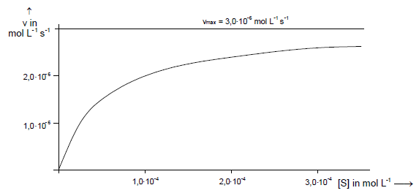

Often the relationship between *v* and *[S]* is shown in a so called Lineweaver-Burk-Plot

$\frac{1}{v}=f\left(\frac{1}{[S]}\right)$.

|  |
| --- |
| 6.8 Show that $\frac{1}{v}=\frac{K_{M}}{v_{max}}∙\frac{1}{\left[S\right]}+\frac{1}{v_{max}}$. |
|  |

The table below shows the initial reaction rates depending on substrate concentration at an enzyme concentration of *E*tot = 1.0∙10-9 mol L-1:

|  |  |  |  |  |
| --- | --- | --- | --- | --- |
| [S]0 ⋅10-6 in mol L-1 | 3.0 | 5.0 | 10 | 20 |
| v0 ⋅10-5 in mol L-1min-1 | 1.06 | 1.55 | 2.37 | 3.21 |

|  |
| --- |
| 6.9 Determine the Michaelis constant KM and the rate constant kb from the Lineweaver-Burk- plot. |
|  |

A different enzyme reaction yielded a Michaelis constant of *KM*= 1.5∙10-5 mol∙L-1. The initial substrate concentration is [S]=3∙10-5 mol∙L-1.

|  |
| --- |
| 6.10 Calculate the fraction of enzyme molecules (fES) that bind substrate. |
|  |

Problem 7 6 points

Evaporating and Cooling

The enthalpy of vaporization of a solvent depends on the concentration of compounds dissolved in it. It is not always simple to measure it. The Bubble Column Evaporator is an interesting method for that purpose. It can also serve as a didactic experiment in studies (J. Chem. Educ. 2016, 93, 1642-1646).



In the experiment dry gas bubbles (1-3 mm diameter) rise from the bottom of the column through a salt solution. Within a few tenths of a second, the interior of the bubbles is saturated with water vapor. This evaporation process withdraws heat from the water. Hence the temperature at the top (*T*o) of the experimental setup is lower, than at the bottom (*T*u). After some time, the system reaches steady state, at which both temperatures do not change any more. Hence the heat delivered via the dry bubbles exclusively evaporates water. This does not withdraw heat from the solution. One can hence balance the energy loss as follows:

Energy loss of the bubbles = Enthalpy of vaporization

$${V⋅(c}_{p}ΔT+Δp)=V∙ ρ_{V}⋅Δ_{vap}H$$

Here, $ΔT=T_{u}-T_{o}$ means the difference in temperature between bottom and top end, , *c*p the specific heat capacity of the gas (in Jm–3K–1); Δ*p* is the difference in pressure between the gas flowing into the system and the gas leaving the solution at atmospheric pressure; *ρ*V is the the density of water vapor. Dividing this equation by *V* yields Energy per Volume.

Below find the data for an experiment carried out with 0.5M NaCl solution:

|  |  |
| --- | --- |
| Inlet temperature *T*u | 54.0°C |
| Outlet temperature *T*o | 21.5°C |
| Heat capacity of the gas used *cp* | 1204 Jm-3K-1 |
| Water vapor density *ρ*V (at *T*o) | 1.030 mol m-3 |
| Inlet pressure *p*u | 105453 Pa |
| Outlet pressure (atmospheric pressure) *p*o | 101325 Pa |
| Gas flow rate | 0.18 L s-1 |

Further data:

|  |  |
| --- | --- |
| *cp* (air) | 1.008 J g–1K–1 |
| *cp* (N2) | 1.040 J g–1K–1 |
| To simplify, one can assume that air consists of 21.0% Oxygen and 79.0% Nitrogen. | |

To get an impression of heat quantities, let us begin with a little story from winter: someone left the windows of lecture hall “Scientia” (Latin for “Science”; the room where this test takes place) open overnight. Temperature dropped to -5°C.

|  |
| --- |
| 7.1 Calculate the energy necessary to reheat the air in the room to 22°C (at atmospheric pressure). |
|  |

Let us switch back to the bubble experiment according to the figure above.

|  |
| --- |
| 7.2 Calculate the number of gas bubbles occurring per second, assuming a mean bubble diameter of 2mm. |
|  |

|  |
| --- |
| 7.3 Tick the correct boxes |
| |  |  | | --- | --- | | When rising through the column, pressure in the gas | □ increases | | □ decreases | |   □ Work is performed on the bubbles.  □ The bubbles perform work.   |  |  |  | | --- | --- | --- | | This work needs to be | □ added | to/from the heat transferred by the | | □ subtracted |   gas to calculate the Enthalpy of Vaporization. |
| 7.4 Calculate the Enthalpy of Vaporization ΔvapH determined during the experiment above. |
|  |
| 7.5 Use calculation to decide if air or nitrogen had been used for the experiment. |
|  |
| 7.6 Calculate the **vapor pressure of water above the salt solution** from the vapor density **at** temperature To. |
|  |

The Enthalpy of Vaporization of pure water at 16°C is: 2463.0 kJ/kg, its vapor pressure at this temperature is: 1.8188 kPa

|  |
| --- |
| 7.7 Calculate the **vapor pressure of pure water** at To and tick the correct boxes. |
| □ The vapor pressure of water decreases by adding salt.  □ The vapor pressure of water increases by adding salt. |

There were considerations to utilize such a setup on a larger scale for evaporation cooling. For this purpose, an experiment took place using a gas flow rate of 150m3/h. All other parameters (temperatures, pressures, …) remained constant.

|  |
| --- |
| 7.8 Calculate the cooling power of the setup at this flow rate, i.e. at 150m3/h. |
|  |

The air blower used takes in air at atmospheric pressure and generates 262 mbar overpressure. It uses an electric motor that takes up 2.2 kW power. The fraction of power not used for compressing the gas leaves the mechanism in the form of heat.

|  |
| --- |
| 7.9 Calculate the mechanical power of the air blower. |
|  |
| 7.10 Calculate the net cooling power of the setup (air blower + bubble evaporator). |
|  |